# 

# 

# Design Report

### **Selected Problem Statement:**

### **Road accidents involving motorcycles are a major concern, particularly during nighttime driving when reduced visibility significantly increases the risk of collisions. This issue is compounded by overspeeding, which limits motorcyclists' ability to accurately assess their surroundings and react in time to avoid hazards. The lack of effective solutions to enhance visibility and situational awareness for motorcyclists at night exacerbates this problem, leading to a higher likelihood of accidents. Current safety measures, such as helmets, reflective vests, and lighting, are not always sufficient in mitigating these risks. The frequency and severity of these accidents point to the urgent need for more effective solutions that can alert riders to dangerous conditions, reduce speed, and improve their situational awareness, ensuring safer driving practices and ultimately preventing fatalities and injuries.**



### **Alignment to Sustainable Development Goals - 9: Industry, Innovation and Infrastructure**

This problem statement aligns with Sustainable Development Goal 9 (SDG 9): Industry, Innovation, and Infrastructure in several ways:

**Infrastructure Development**

1. **Road Safety Infrastructure:** The problem statement highlights the need for improved road safety infrastructure, such as enhanced lighting and visibility systems, to reduce the risk of accidents involving motorcycles.

2. **Innovative Solutions:** The statement emphasizes the need for innovative solutions to enhance visibility and situational awareness for motorcyclists at night, which aligns with SDG 9's focus on promoting innovation and infrastructure development.

**Industry and Innovation**

1. **Development of New Technologies:** The problem statement suggests the need for new technologies and solutions to address the issue of motorcycle accidents at night, which aligns with SDG 9's focus on promoting innovation and entrepreneurship.

2. **Improvement of Existing Safety Measures:** The statement also highlights the need to improve existing safety measures, such as helmets and reflective vests, which aligns with SDG 9's focus on promoting industry innovation and upgrading.

**Quality, Reliable, Sustainable, and Resilient Infrastructure**

1**. Reducing Road Accidents:** The problem statement aims to reduce road accidents involving motorcycles, which aligns with SDG 9's focus on promoting sustainable and resilient infrastructure.

2. **Enhancing Road Safety**: The statement emphasizes the need to enhance road safety, which aligns with SDG 9's focus on promoting quality, reliable, sustainable, and resilient infrastructure.

By addressing the issue of motorcycle accidents at night, this problem statement contributes to the achievement of SDG 9 by promoting innovation, infrastructure development, and industry upgrading, ultimately leading to improved road safety and reduced accidents.

## 

## **Part I - Analysis of End-User**

**End User: Road users, including drivers, passengers, pedestrians, and cyclists.**

**User problem: Road accidents resulting in injuries, fatalities, and economic losses.**

**Why is the problem important to solve?**

1. **Human Cost:** Road accidents claim millions of lives worldwide each year, causing immense emotional trauma to families and communities.
2. **Economic Burden:** Road accidents result in significant economic losses, including medical expenses, lost productivity, and damage to infrastructure.
3. **Social Impact:** Road accidents can lead to social isolation, reduced mobility, and decreased quality of life for victims and their families.

**Other Stakeholders:**

1. **Government Agencies**: Responsible for road safety regulations, infrastructure development, and enforcement.
2. **Automotive Industry:** Manufacturers of vehicles and safety equipment.
3. **Insurance Companies:** Providers of coverage for road accidents.
4. **Emergency Services:** Responders to road accidents, including police, ambulance, and fire services.
5. **Healthcare Providers:** Treating injuries and providing medical care to accident victims.

**Survey Methodology and Results**

As part of our research on road accidents at nighttime, we conducted a survey to gather insights from drivers on their nighttime driving habits, safety measures, and experiences with road accidents.

**Survey Design and Administration**

The survey consisted of 14 questions, divided into five sections: demographic information, nighttime driving habits, road accident experience, safety measures, and suggestions for improvement. The survey was administered online and in-person to a sample of [insert number] drivers.

**Questionnaire:**

**Section 1: Demographic Information**

1. What is your age? _____
2. Do you own a vehicle?

A. Yes

B. No

**Section 2: Nighttime Driving Habits**

1. How often do you drive at night?
2. Daily
3. Occasionally
4. Rarely

4. What time of night do you usually drive?

1. Peak hours (7-10 pm)
2. Late evening (10 pm-1 am)
3. Early morning (1-5 am)

5. Do you use headlights while driving at night?

1. Always
2. Sometimes
3. Rarely

**Section 3: Road Accident Experience**

5. Have you ever been involved in a road accident at night?

A. Yes

B. No

6. If yes, how many accidents have you been involved in? _____

7. What was the main cause of the accident?

1. Speeding
2. Reckless driving
3. Poor visibility
4. Other (please specify) _____

8. Were you injured in the accident?

1. Yes

2. No

**Section 4: Safety Measures**

9. Do you wear a seatbelt while driving at night?

A. Always

B. Sometimes

C. Rarely

10. Do you use fog lights or high beams while driving at night?

A. Always

B. Sometimes

C. Rarely

**Section 5: Suggestions for Improvement**

11. What do you think can be done to reduce road accidents at night?

1. Improved lighting
2. Better Road conditions
3. Stricter Law enforcement
4. Other:

12. Do you think there should be more public awareness campaigns about nighttime driving safety?

1. Yes
2. No

13. Any other suggestions?

(Open-ended question for respondents to provide additional suggestions)

By understanding the end-user's problem and the stakeholders involved, we can develop effective solutions to reduce road accidents and improve road safety.

**Insights From the user interaction:**

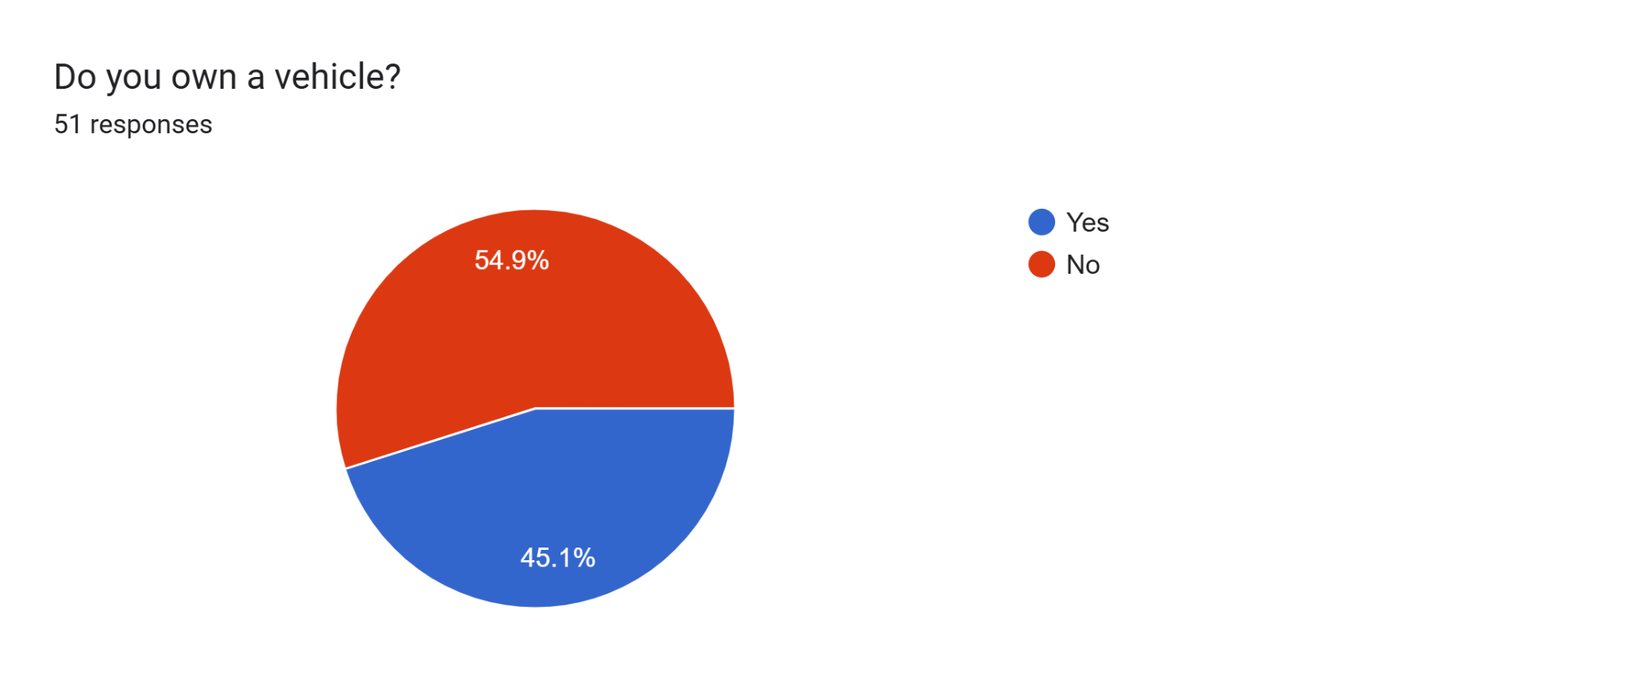

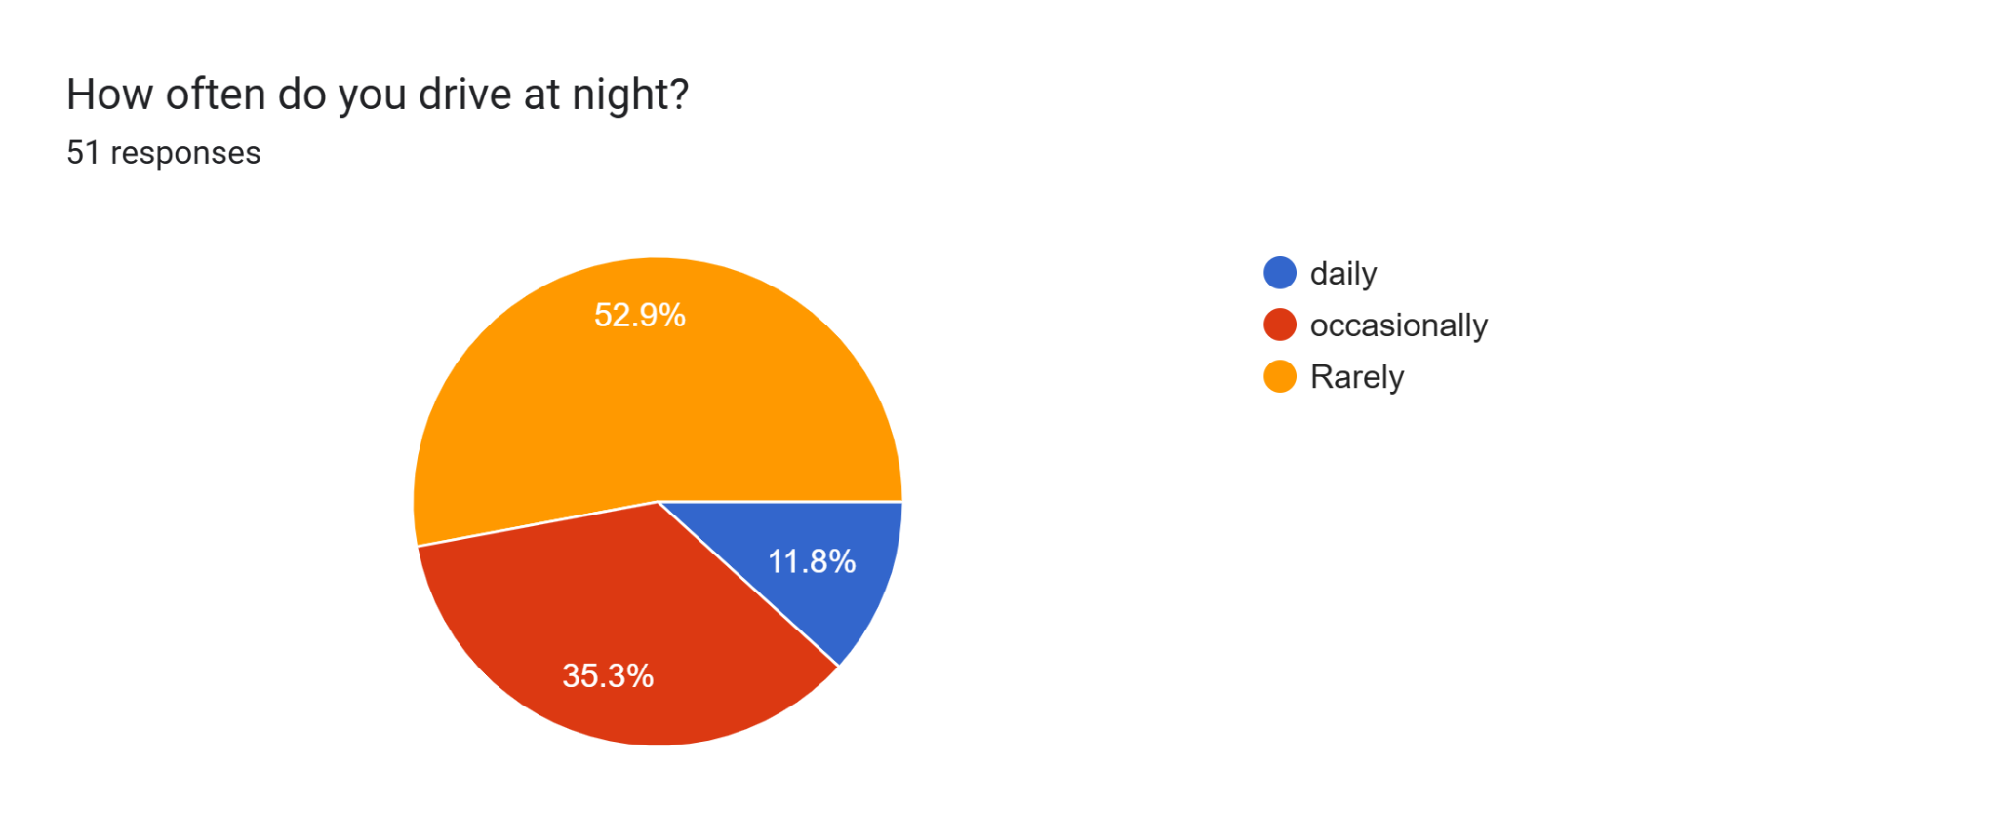

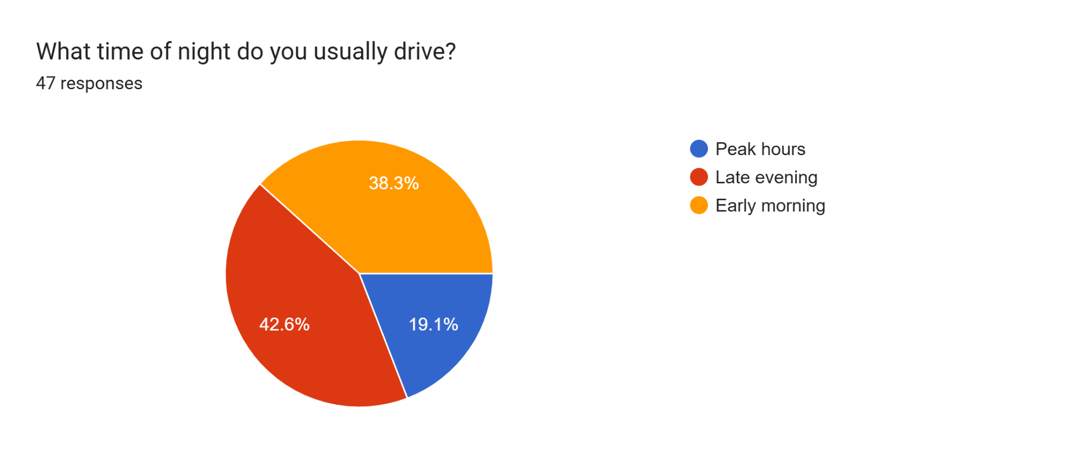

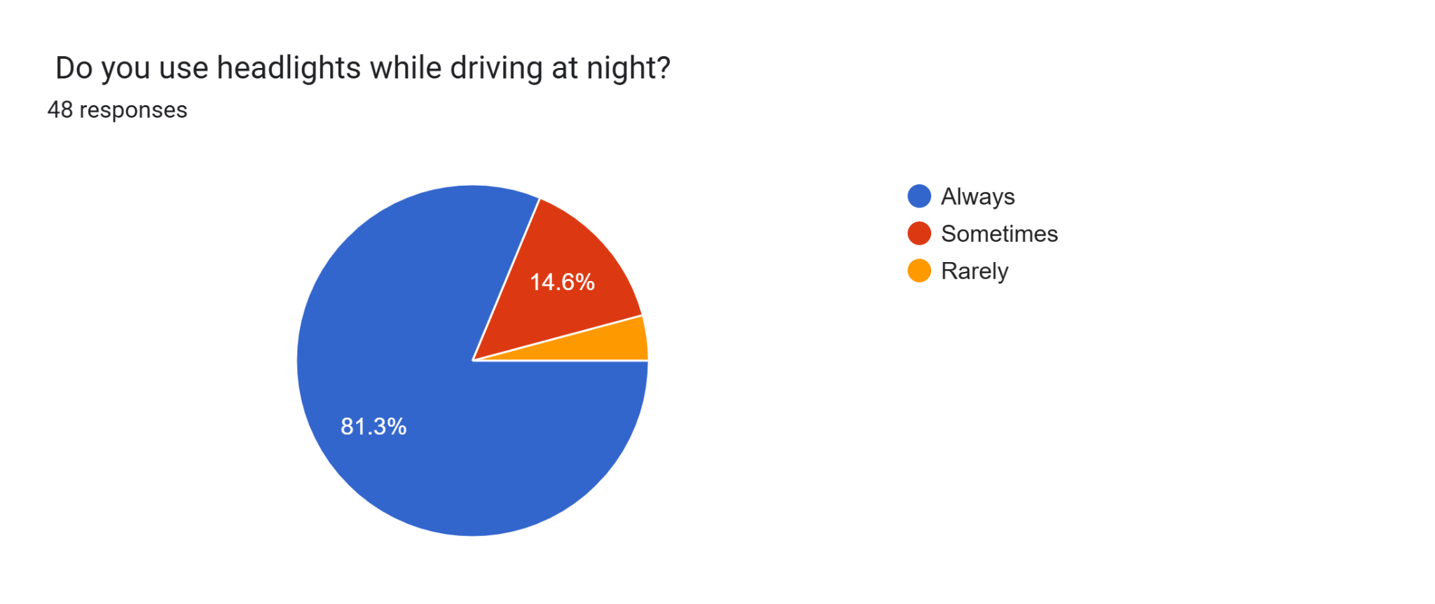

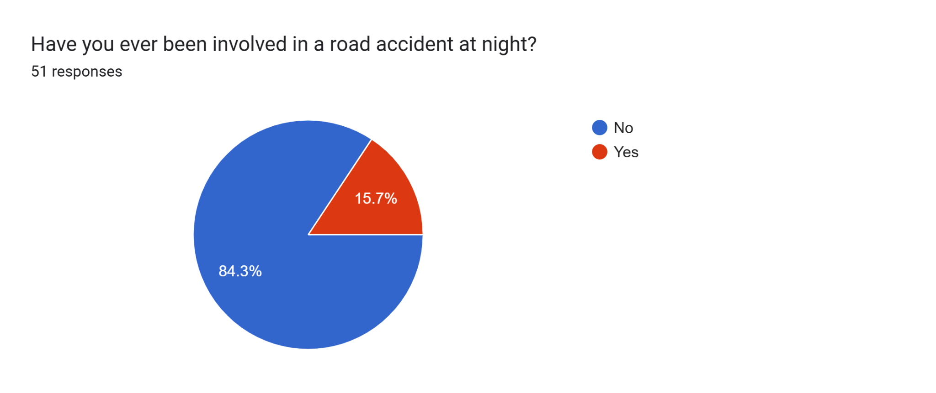

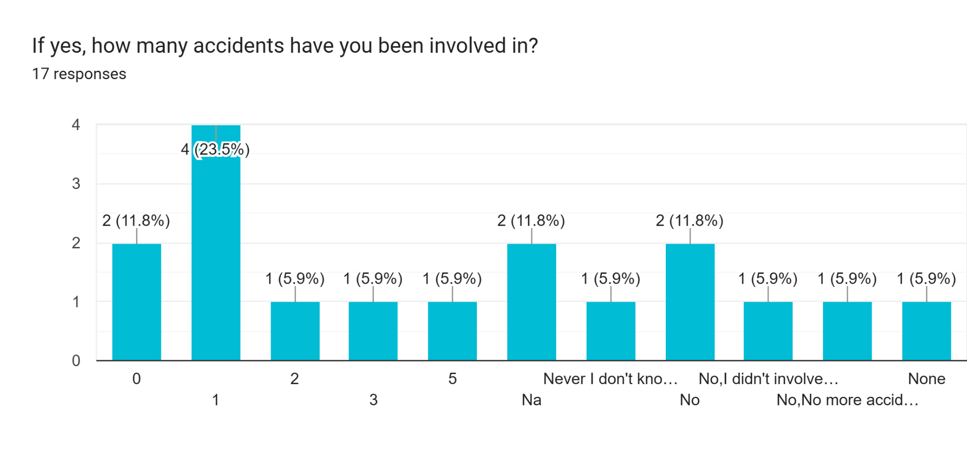

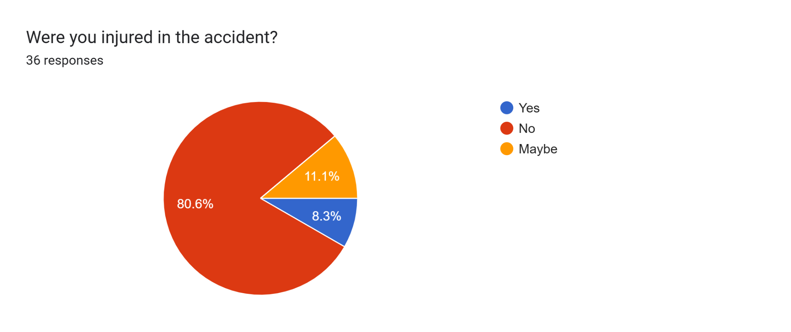

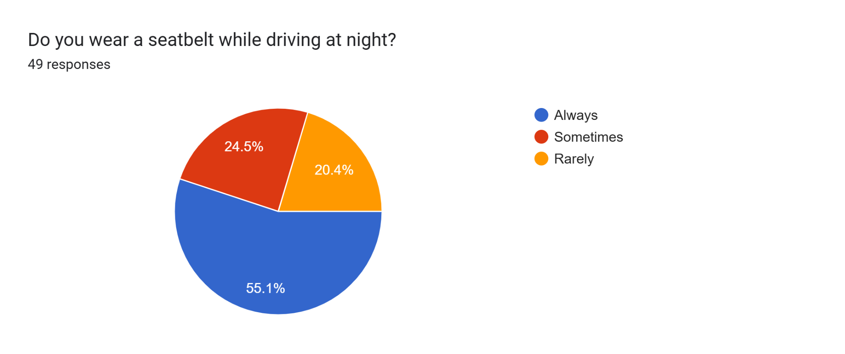

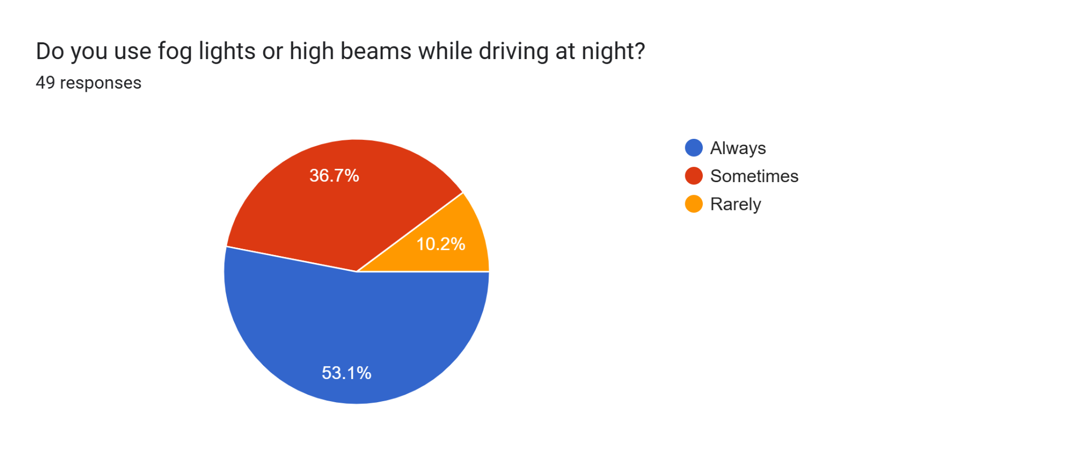

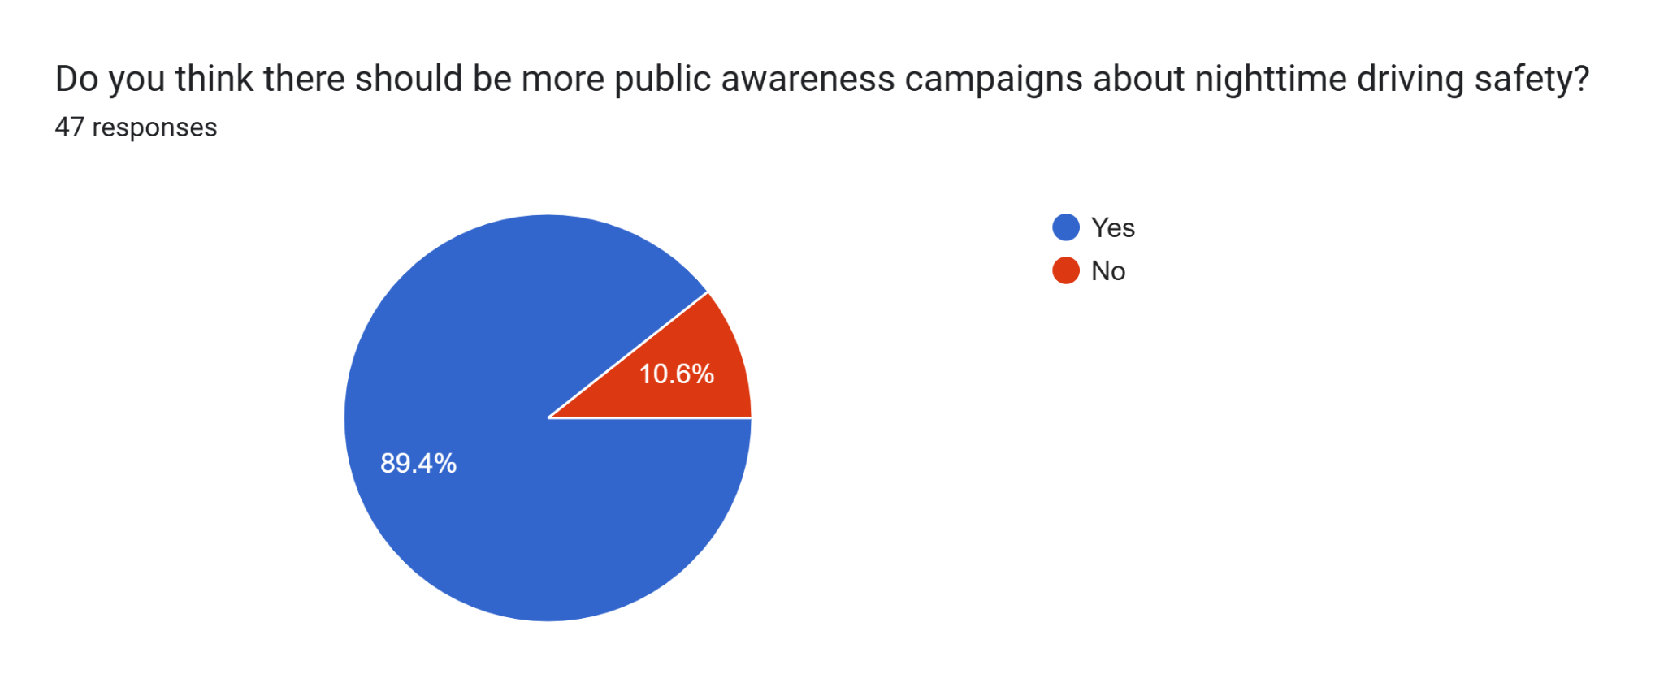

## 

## 

## 

## 

## **Part II - Problem Scoping to Identify Design Requirements**

**Insights from User Interaction:**

1. Drivers, pedestrians, and cyclists face visibility challenges at nighttime, increasing the risk of accidents.
2. Insufficient lighting on roads and sidewalks contributes to accidents.
3. Distracted driving and speeding are common causes of nighttime accidents.
4. Emergency services and medical treatment are critical in the event of an accident.

**USER INTERACTION DESCRIPTION WITH EVIDENCE**

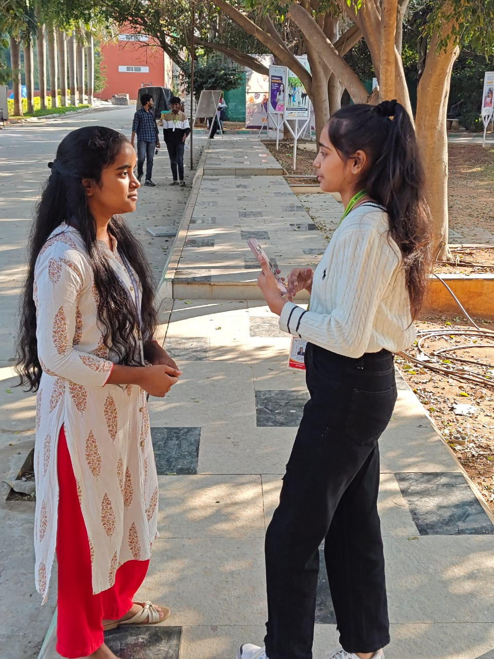

- **What do users need or want?**

1. Improved visibility and safety at night.
2. A system that minimizes distractions but enhances awareness.
3. An affordable, low-maintenance solution.
4. Reliable, durable infrastructure or device that can be used year-round.

**Criteria (Design Requirements):**

1. **Efficiency :** Reduce the number of nighttime accidents by 20% within the first year of implementation.
2. **Ease of Use:** Design a solution that is intuitive and easy to use for drivers, pedestrians, and cyclists.
3. **Cost:** Develop a cost-effective solution that can be implemented within a budget of 20,000 Rupees.
4. **Durability:** Design a solution that can withstand various weather conditions and last for at least 5 years.
5. **Safety:** Ensure the solution does not create new hazards or distractions for road users.

**Constraints:**

1. **Infrastructure:** Solution must be compatible with existing road infrastructure.
2. **Regulations:** Comply with local and national regulations regarding road safety and lighting.
3. **Environmental Impact:** Minimize environmental impact and avoid disrupting local ecosystems.
4. **Maintenance:** Design a solution that requires minimal maintenance and upkeep.

### **Evaluation of Solution proposed based on Design Requirements**

1. **Criteria:**

|  |  |  |
| --- | --- | --- |
| **Criteria** | **Design Metric** | **Unit** |
| Efficiency | Accident reduction rate | 55-75% |
| Ease of Use | User feedback on usability | 9/10 |
| Cost | Implementation of cost | 16,500Rupees |
| Durability | Lifespan of Solution | 7-10 Years |
| Safety | Incident reports after implementation | 0 |

1. **Constraints:**

|  |  |  |
| --- | --- | --- |
| **Constraints** | **Design Metric** | **Unit** |
| Budget | Total cost | 20,000Rupees |
| Regulations | Compliance Rate | 90% |
| Environmental Impact | Carbon footprint and environmental disruption | 20-150 g CO2/kWh, environmental disruption  3/10 |
| Maintenance | Frequency of maintenance required | Maintenance intervals  6 months |

## 

## 

**Part III: Ideation**

**Our team generated a list of innovative ideas to address the problem of road accidents at nighttime. Here are the different ideas we drafted:**

1. **Smart Road Lighting System:** Implement an intelligent road lighting system that adjusts brightness and color based on real-time traffic conditions, weather, and time of day.

A Smart Road Lighting System is designed to make street lighting more efficient, adaptive, and sustainable. Here's how it works:

### **Key Features of Smart Road Lighting System**

**Brightness Adjustment**:

* + **Real-time Traffic Conditions**: The system uses sensors to detect traffic density and adjusts the brightness accordingly. For instance, during high traffic periods, the lights become brighter to ensure maximum visibility and safety.
  + **Weather Conditions**: It can detect adverse weather conditions like fog, rain, or snow, and increase the brightness to improve visibility for drivers and pedestrians.
  + **Time of Day**: The lighting levels are adjusted according to the time of day, ensuring energy savings during off-peak hours (like late at night) by dimming the lights when there’s minimal traffic.

**Color Adjustment**:

* + **Nighttime Safety**: Cooler, blue-toned lights can be used at night to enhance visibility and concentration for drivers.
  + **Pedestrian Areas**: Warmer, amber lights can be employed in pedestrian-heavy areas to create a more welcoming and safe environment.

**Automation and Control**:

* + **Centralized Control**: Authorities can monitor and control the lighting system remotely, allowing for quick adjustments when needed.
  + **Energy Efficiency**: By adapting to real-time conditions, the system conserves energy and reduces operational costs.

**Environmentally Friendly**: By using energy-efficient LED lights and minimizing unnecessary light usage, the system reduces the carbon footprint and light pollution.

### **Scenario Example**

Imagine driving on a smart road at night:

* **Low Traffic Hours**: The streetlights are dimmed to save energy.
* **Sudden Rain**: As it starts to rain, the sensors detect reduced visibility and increase the brightness of the lights.
* **Approaching a Busy Intersection**: The lights become brighter to ensure safety as cars and pedestrians are more frequent

2. **Glow-in-the-Dark Road Markings**

Apply glow-in-the-dark materials to road markings, pedestrian crossings, and traffic signs to increase visibility at nighttime.

Glow-in-the-dark road markings utilize photoluminescent materials that absorb and store ambient light during the day, and then glow in the dark to enhance nighttime visibility. Here’s how they work and their benefits:

### **How It Works**

* **Photon Absorption**: During the day, the photoluminescent materials absorb light energy from natural sunlight or artificial sources.
* **Energy Storage**: The absorbed light energy is stored within the material.
* **Light Emission**: At night or in low-light conditions, the stored energy is gradually released as visible light, causing the material to glow.

### **Applications**

**Road Markings**: White or colored lines along roads that help in lane identification, direction, and alignment can be made more visible at night.

**Pedestrian Crossings**: Glow-in-the-dark materials on pedestrian crossings make them more noticeable to both drivers and pedestrians, improving safety.

**Traffic Signs**: Enhance the visibility of critical signs like speed limits, warnings, and directions during dusk, dawn, and night.

### **Benefits**

* **Increased Safety**: Improves visibility for drivers and pedestrians, reducing accidents and enhancing overall safety at night.
* **Energy Efficiency**: No need for electricity or additional power sources, as they use stored ambient light.
* **Low Maintenance**: Durable and long-lasting, these materials can provide glow effects for many hours after dark.
* **Environmental Impact**: Reduces the need for artificial lighting, contributing to lower carbon emissions and energy consumption.

### **Example in Use**

Consider a rural highway:

* **Daytime**: The road markings and signs absorb sunlight.
* **Nighttime**: These same markings and signs emit a glow, illuminating the driving path and making navigation safer without the aid of additional lighting.

3. **Driver Alert System**

Develop a driver alert system that uses sensors and cameras to detect potential hazards, such as pedestrians, animals, or obstacles, and alerts drivers through visual and auditory warnings.

A **Driver Alert System** is designed to enhance road safety by using advanced sensors and cameras to detect potential hazards. Here's a detailed breakdown:

### **How It Works**

#### **Sensors and Cameras:**

* **Cameras**: Positioned around the vehicle to provide a 360-degree view, these help in identifying objects, pedestrians, and animals.
* **Ultrasonic Sensors**: Detect nearby obstacles by emitting sound waves that bounce back from objects.
* **Radar Sensors**: Measure the distance to objects and their speed, effective over longer ranges.
* **Infrared Sensors**: Useful in low-light conditions or at night to detect heat signatures of living beings like pedestrians and animals.

#### **Data Processing:**

* **Real-time Analysis**: The system processes the input from sensors and cameras in real time to identify potential hazards.
* **Machine Learning & AI**: These technologies are used to recognize patterns, differentiate between types of obstacles, and predict potential threats based on the behavior of detected objects.

#### **Alerts and Warnings:**

* **Visual Alerts**: Displayed on the car’s dashboard or Head-Up Display (HUD), showing icons or highlighting the location of the hazard.
* **Auditory Warnings**: Beeping sounds or voice alerts that inform the driver of approaching hazards.
* **Haptic Feedback**: Includes vibrations in the steering wheel or seat to alert the driver by sense of touch.

### **Benefits**

1. **Enhanced Safety**: By providing early warnings, the system can prevent collisions with pedestrians, animals, and other obstacles.
2. **Reduced Accidents**: Helps in minimizing accidents, especially in areas with poor visibility or during adverse weather conditions.
3. **Driver Assistance**: Supports drivers in maintaining focus and increasing reaction time to sudden hazards.
4. **Adaptive Features**: Some systems can automatically engage braking or steering control to avoid collisions.

### **Scenarios**

* **City Driving**: Detects pedestrians crossing the road unexpectedly and alerts the driver, reducing the likelihood of accidents.
* **Highway**: Identifies vehicles in blind spots and provides warnings during lane changes.
* **Rural Areas**: Detects animals on the road and alerts the driver to slow down.

4. **Smart Pedestrian Crossing**

Design a smart pedestrian crossing that uses sensors and LED lights to detect pedestrians and alert drivers, providing a safer crossing experience.

A Smart Pedestrian Crossing leverages modern technology to enhance the safety of pedestrians and improve driver awareness. Here’s an in-depth look at how it works:

### **Key Components**

1. **Sensors**:
   * **Infrared Sensors**: Detect the presence of pedestrians by sensing heat signatures.
   * **Pressure Sensors**: Embedded in the crosswalk to register the weight of pedestrians when they step on it.
   * **Motion Sensors**: Identify movement within the designated crosswalk area.
2. **LED Lights**:
   * **In-road LEDs**: Installed along the edges of the crosswalk to highlight it, especially at night or in low-light conditions.
   * **Overhead LEDs**: Positioned above the crossing to increase visibility from a distance.
   * **Signal LEDs**: Integrated into traffic lights to indicate the status of the crossing to both pedestrians and drivers.

### **Operation**

#### **Pedestrian Detection:**

#### When a pedestrian approaches or enters the crosswalk, the sensors detect their presence.

* The system then automatically activates the LED lights to illuminate the crossing.

#### **Driver Alerts:**

* **Visual Alerts**: LED lights embedded in the road and overhead flash to warn approaching drivers that pedestrians are crossing.
* **Auditory Alerts**: In some systems, an audible signal can be emitted to further alert drivers.

#### **Adaptive Lighting:**

* The brightness of the LED lights can adjust according to ambient light conditions, being brighter at night or during bad weather and dimmer during the day.
* Color changes in the LED lights (e.g., red for stop, green for go) can be used to signal drivers and pedestrians on the crossing's status.

### **Benefits**

1. **Increased Safety**: Enhances the visibility of pedestrians, particularly in poorly lit areas, reducing the risk of accidents.
2. **Improved Driver Awareness**: Alerts drivers to the presence of pedestrians well in advance, allowing for safer and more controlled driving behavior.
3. **Energy Efficiency**: Uses energy-efficient LEDs and sensor technology to ensure minimal power consumption.
4. **Real-time Monitoring**: The system can be integrated with central traffic management systems for real-time monitoring and control, enabling quick response to any issues.

### **Example Scenario**

Imagine a busy city street where pedestrians need to cross frequently:

* **Approach Detection**: As a pedestrian nears the crossing, motion and infrared sensors detect their presence.
* **LED Activation**: The crosswalk lights up with bright, flashing LEDs embedded in the road to signal drivers to slow down and prepare to stop.
* **Crossing Signal**: Overhead LEDs and traffic signals guide both pedestrians and drivers, changing colors to coordinate safe crossing periods.
* **Safety Ensured**: Drivers receive an early visual and, in some cases, auditory warning, minimizing the likelihood of accidents, especially in high-traffic areas or during low visibility conditions.

## **Part IV - Final Solution Proposed**

### ***Solar panel street lights***

**Justification:**

We selected this idea because it addresses the root cause of nighttime accidents: poor visibility. By constructing solar street lights , we can significantly improve visibility, reduce accidents, and enhance overall road safety. This solution also integrates safety features, making it a comprehensive approach to addressing nighttime road safety.

**3D model of the proposed idea:**

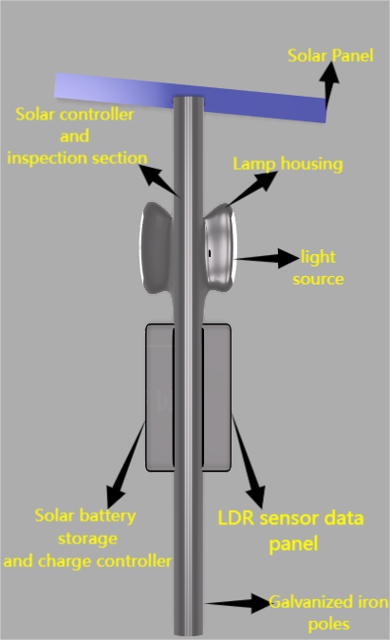

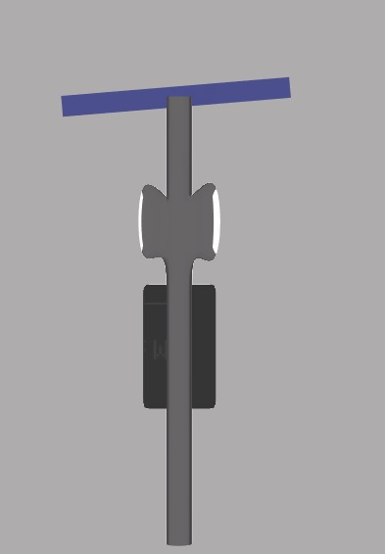

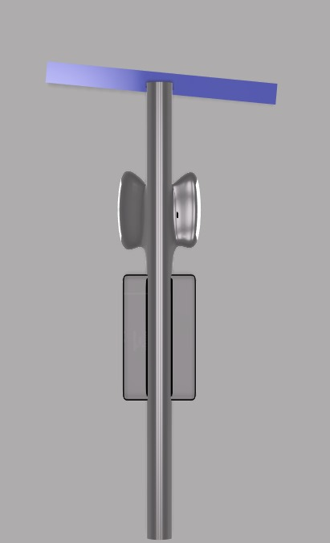

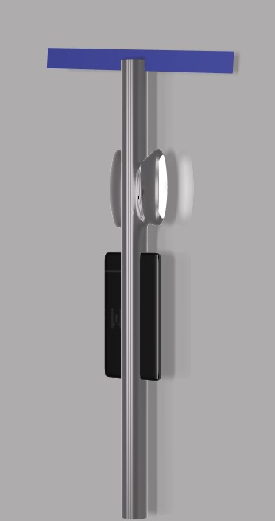

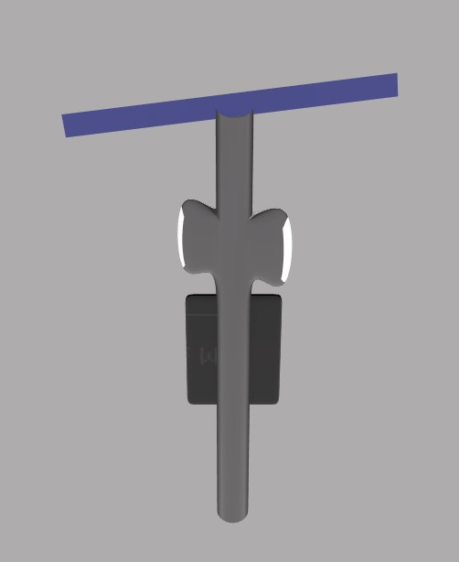

**Description:**

**Automatic street lights are a common sight in urban and suburban areas, providing illumination during the night and switching off automatically during the day. These lights incorporate a built-in sensor, typically a photoresistor or light-dependent resistor (LDR), that detects changes in ambient light levels.**

**Components:**

1. **Solar Panels:** High-efficiency solar panels to harness renewable energy and power the lighting system.

2. **LED Lighting:** Energy-efficient LED lights with adjustable brightness and color temperature to optimize visibility and minimize energy consumption.

3. **Smart Sensors**: Advanced sensors to detect and respond to real-time traffic conditions, weather, and road hazards.

**Features:**

1. **Autonomous Operation:** The system operates autonomously, adjusting lighting conditions based on real-time data.

2. **Energy Efficiency:** Solar panels and energy-efficient LED lights minimize energy consumption and reduce carbon emissions.

3. **Improved Safety:** Smart sensors and AI-powered control system enhance safety by detecting potential hazards and adjusting lighting conditions accordingly.

**How They Work**

* **Dusk:** As the sun sets and the ambient light intensity decreases, the LDR's resistance increases.
* **Threshold Reached:** When the resistance of the LDR reaches a predetermined threshold, the sensor triggers a relay or switch.
* **Light Activation:** The relay or switch connects the power supply to the lamp, turning it on.
* **Dawn:** As the sun rises and the ambient light intensity increases, the LDR's resistance decreases.
* **Light Deactivation:** When the resistance falls below the threshold, the sensor triggers the relay or switch again, disconnecting the power supply and turning off the lamp.

**Benefits:**

1. **Reduced Energy Consumption:** Solar panels and energy-efficient LED lights minimize energy consumption and reduce carbon emissions.

2. **Improved Safety:** Smart sensors and AI-powered control systems enhance safety by detecting potential hazards and adjusting lighting conditions accordingly.

3. **Increased Efficiency**: Autonomous operation and real-time monitoring optimize energy efficiency and reduce maintenance costs.

4. Enhanced Sustainability: Solar-powered systems reduce reliance on fossil fuels and promote sustainable energy practices.

**UTILITY OF OUR STREET LIGHT MOONLIT IN REDUCING THE ACCIDENTS**

Solar street lights equipped with Light Dependent Resistors (LDR) and sensors offer several advantages over traditional street lights in reducing road accidents, especially in India:

1. **Automated Lighting Control**: LDR sensors detect ambient light levels and automatically switch street lights on or off. This ensures street lights are always on during low light situations, providing consistent illumination and minimizing the risk of accidents due to poor visibility.
2. **Energy Efficiency**: Solar street lights are powered by solar panels, reducing reliance on the electrical grid. This means they are more reliable during power outages and reduce operating costs significantly. The automatic control also saves energy by adjusting the light intensity based on the presence of vehicles or pedestrians1.
3. **Enhanced Visibility**: Advanced sensors can adjust the brightness of the lights based on the detected activity. For instance, an IR sensor can increase light intensity when vehicles approach, providing better visibility for drivers and decreasing the likelihood of collisions.
4. **Accident Detection Systems**: Some systems integrate accident detection, which can alert emergency services promptly. This quick response can be crucial in reducing the severity of injuries and saving lives2.
5. **Sustainability**: Solar street lights utilize renewable energy, contributing to a reduction in carbon emissions. This aligns with India's initiatives for sustainable development and reducing the environmental impact of urban infrastructure.
6. **Maintenance and Operational Costs**: With solar street lights, the running and maintenance costs are lower because they require less frequent interventions and are built to last longer. These lower costs can free up resources for other critical road safety measures.

By providing better visibility, automated control, and reliable lighting, solar street lights with LDR sensors make roads safer and help decrease the number of road accidents. This can be particularly beneficial in rural and remote areas in India, where access to consistent and reliable electricity may be limited

## **Part V – Conclusion and Future Scope**

**Conclusion:**

Our project focused on designing a sustainable and innovative solution to reduce road accidents at nighttime. Through research, ideation, and prototyping, we developed a Solar-Powered Smart Street Lighting System. This system combines energy-efficient LED lighting with solar panels and smart sensors to provide a reliable, adaptive, and safe lighting solution for roads and public spaces.

**Key Takeaways:**

1. Solar-powered street lights offer a sustainable and energy-efficient solution for outdoor lighting.

2. Smart sensors and AI-powered control systems can enhance safety and optimize energy efficiency.

3. Innovative design and technology can improve road safety and reduce accidents.

**Future Scope:**

1. **Integration with Existing Infrastructure:** Collaborate with municipalities and transportation agencies to integrate our system with existing infrastructure.

2. **Expansion to Other Applications:** Explore applications in rural areas, parking lots, and pedestrian walkways.

3. **Advanced Sensor Technologies:** Integrate advanced sensor technologies, such as lidar and radar, to enhance safety and detection capabilities.

4. **Energy Storage and Grid Integration:** Develop more efficient energy storage systems and explore grid integration options to optimize energy efficiency.

5. **Public Awareness and Education:**Launch public awareness campaigns to educate drivers, pedestrians, and cyclists about the importance of road safety and the benefits of our system.